**TEAM INFORMATION**

* **Project Title:** Optimizing User, Group, and Role Management with Access Control and Workflows
* **Team ID: NM2025TMID15119**
* **Team Size:** 5
* **Team Leader:** YOGESHWARAN S
* **Team Member 1:** HARIKRISHNAN S
* **Team Member 2:** MUKESHM
* **Team Member 3:** BALACHANDRAN S
* **Team Member 4:** GOWTHAM RAJ R

**PROBLEM STATEMENT :**

Organizations often face difficulties in managing users, groups, roles, and access permissions in a consistent and secure manner. Without an automated solution, workflows become prone to errors, leading to inefficiency and lack of accountability.

**OBJECTIVE :**

**The goal of this project is to design and configure a ServiceNow Workflow Management System that streamlines:**

* User, group, and role management
* Table creation and application access
* Role-based security through Access Control Lists (ACLs)
* Automation of workflows using Flow Designer

This ensures structured operations, controlled access, and smooth task execution.

**SKILLS UTILIZED :**

* ServiceNow administration
* User, group, and role management
* Table and module configuration
* Application access management
* ACL implementation
* Flow Designer automation

**TASK INITIATION :**

The following milestones outline the step-by-step development of the ServiceNow workflow management system.

**STEP 1: USERS**

**Create Users**

1. Log in to ServiceNow.
2. In the Application Navigator, go to All → Users.
3. Under System Security, select Users.
4. Click on New.
5. Enter the required details for the first user (e.g., *alice p*).
6. 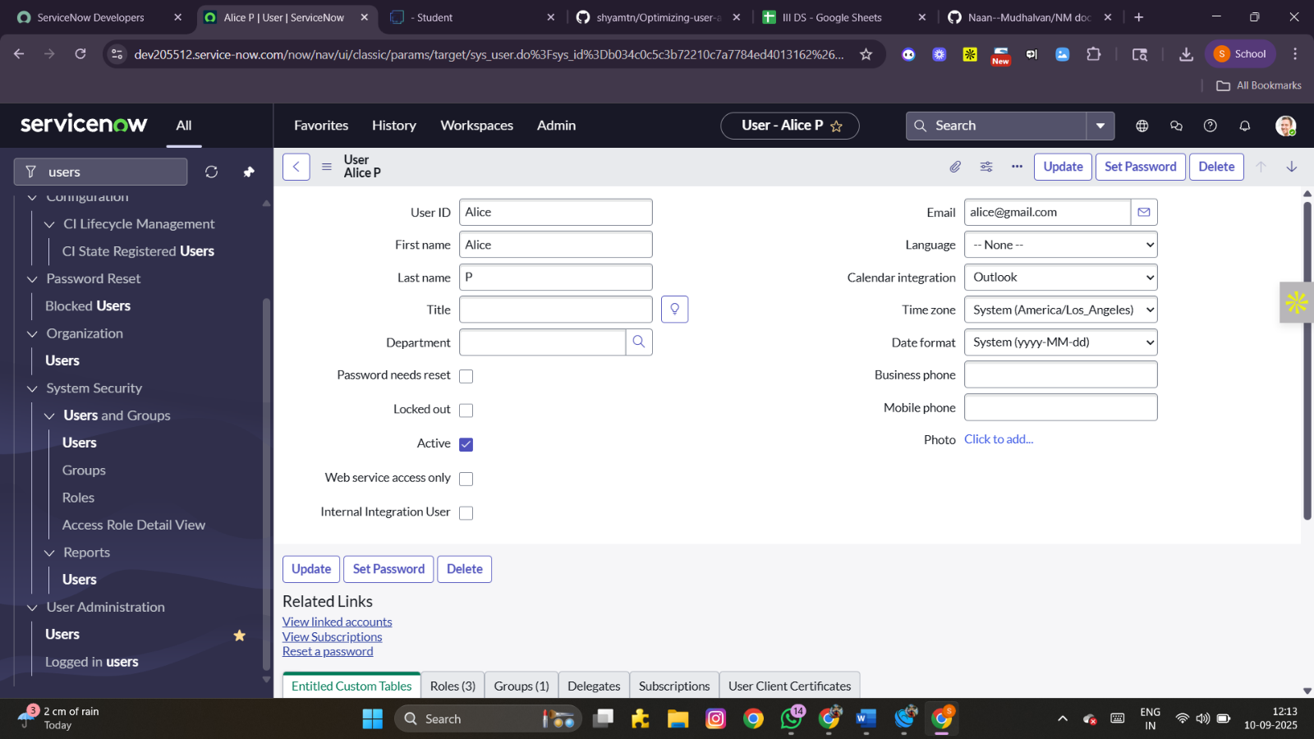Click Submit.

**Create a second user:**7. Add another user (e.g., *bob p*) by repeating the steps above.  
8.Click Submit.

**STEP 2: GROUPS**

**Create Groups**

1. Open ServiceNow.
2. Navigate to All → Groups.
3. Under System Security, select Groups.
4. Click on New.
5. Provide the necessary details to define a group (e.g., *Project Team Group*).
6. Click Submit.

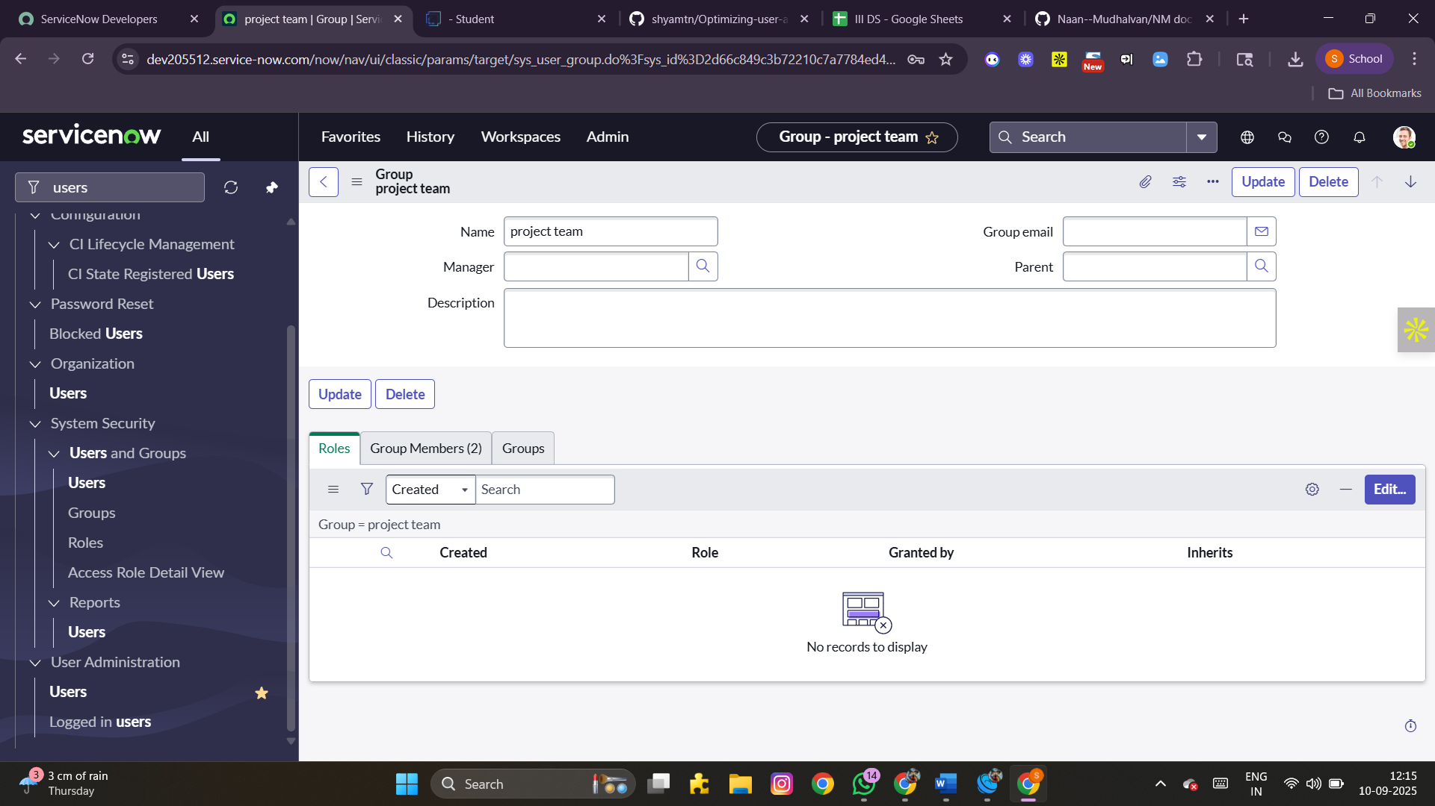

**STEP 3: ROLES**

**Create Roles**

1. Log in to ServiceNow.
2. Go to All → Roles.
3. Under System Security, choose Roles.
4. Click New.
5. Fill in the fields to create a new role (e.g., *Project Manager*).
6. Click Submit.

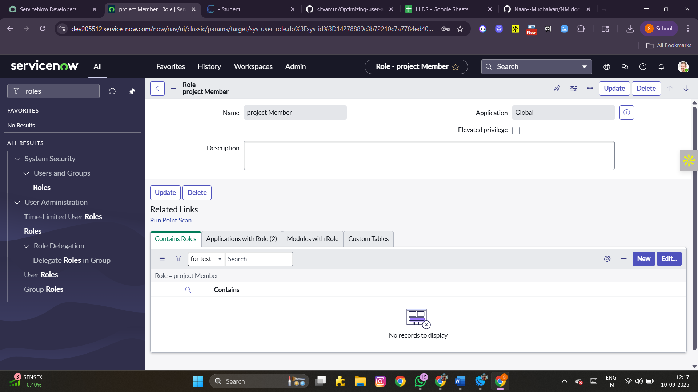 **Create another role:**7. Add a second role (e.g., *Team Member*).  
8. Click Submit.

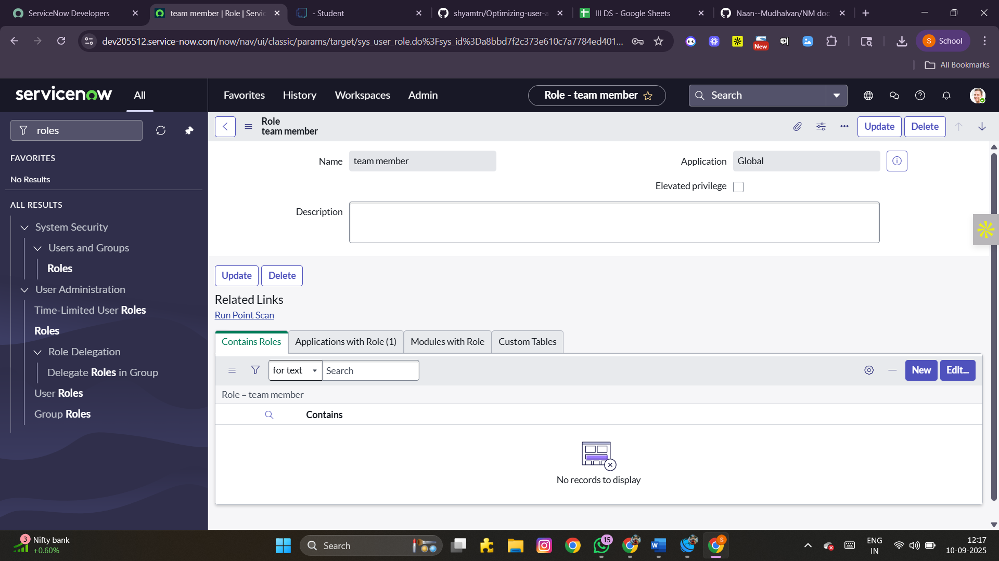

**STEP 4: TABLE**

**Create Tables**

1. Access ServiceNow.
2. Navigate to All → Tables.
3. Select Tables under System Definition.
4. Click New.
5. Provide the following details:
   * Label: project table
   * Check the boxes: *Create module* and *Create mobile module*
6. Set the menu name as *project table*.
7. Add the required columns.
8. Click Submit.

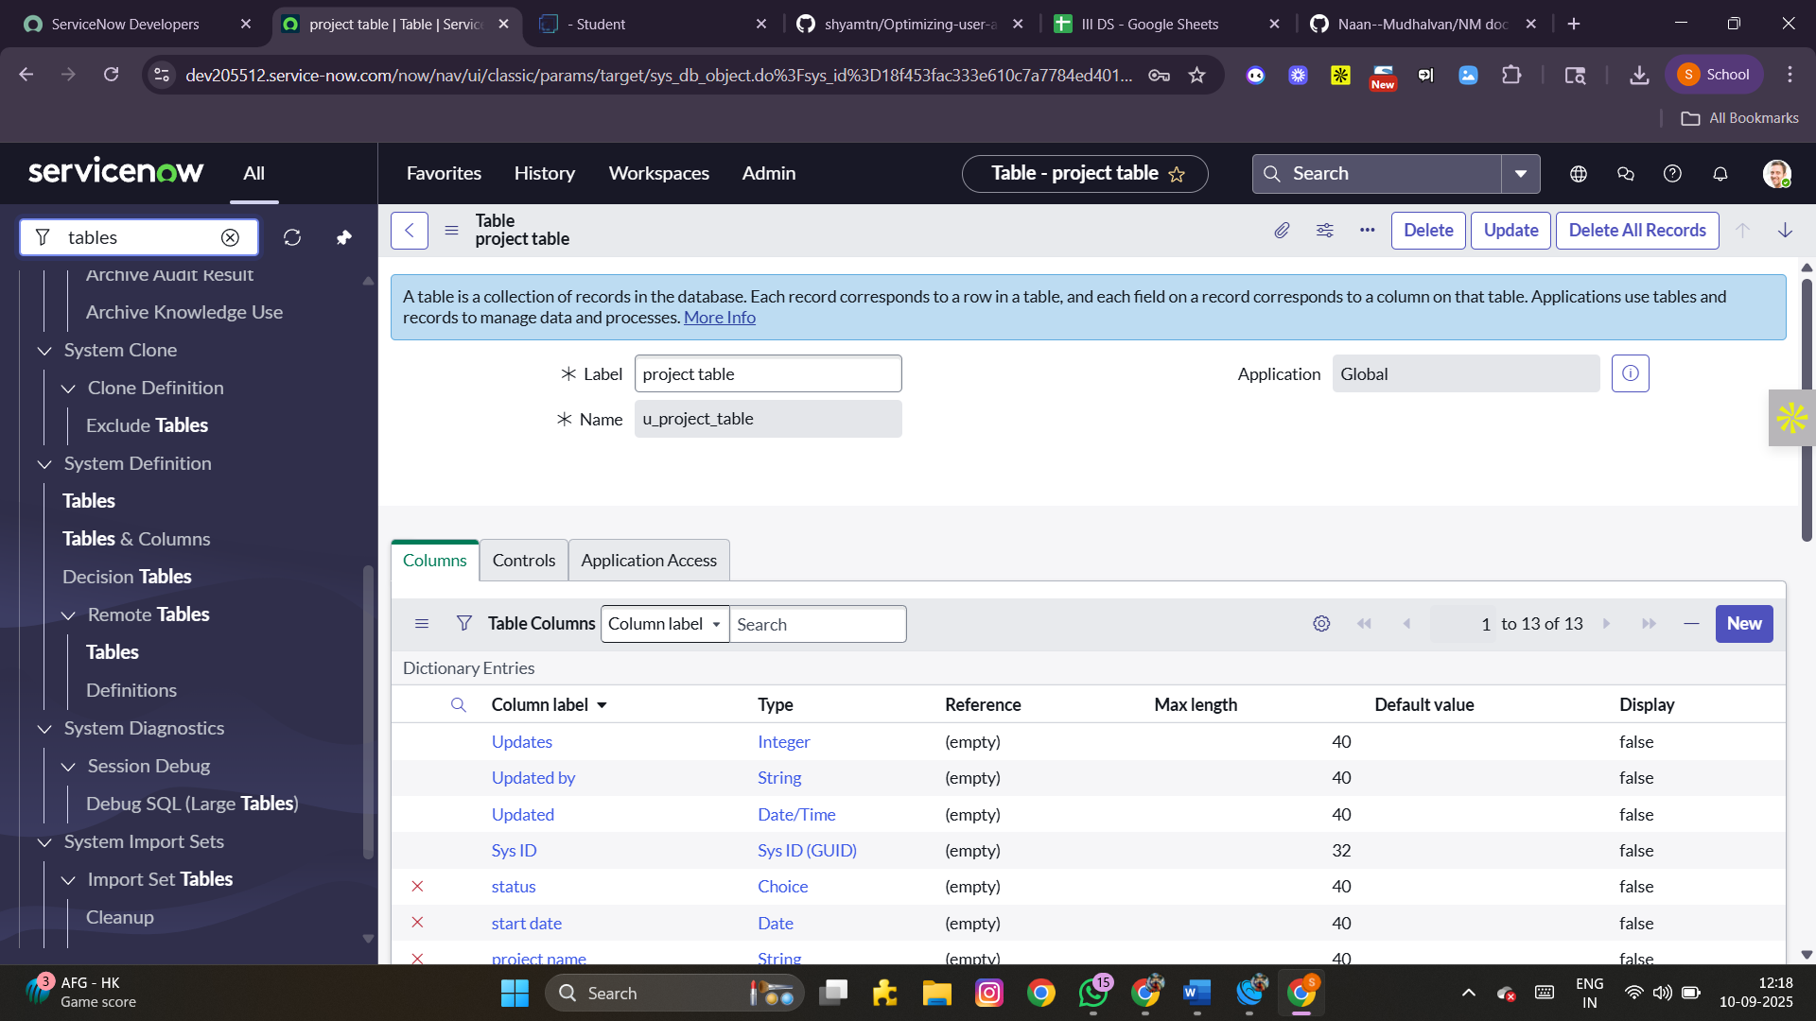 **Create an additional table:**9. Add another table named *task table2*.  
10. Fill in the required details and click Submit.

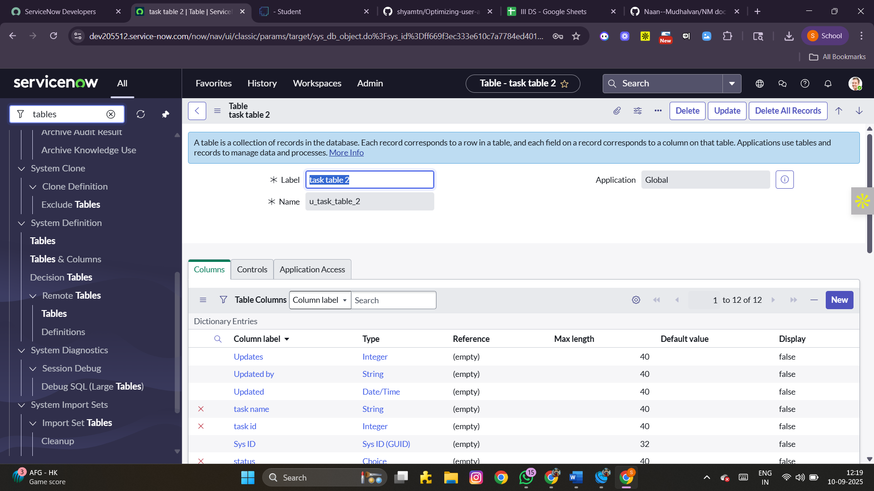

**STEP 5: ASSIGN USER TO GROUPS**

**Assign Users to Project Team Group**

1. In ServiceNow, navigate to All → Groups.
2. Select the Project Team Group.
3. Open the Group Members tab.
4. Click Edit.
5. Add *alice p* and *bob p* as members.
6. Click Save.

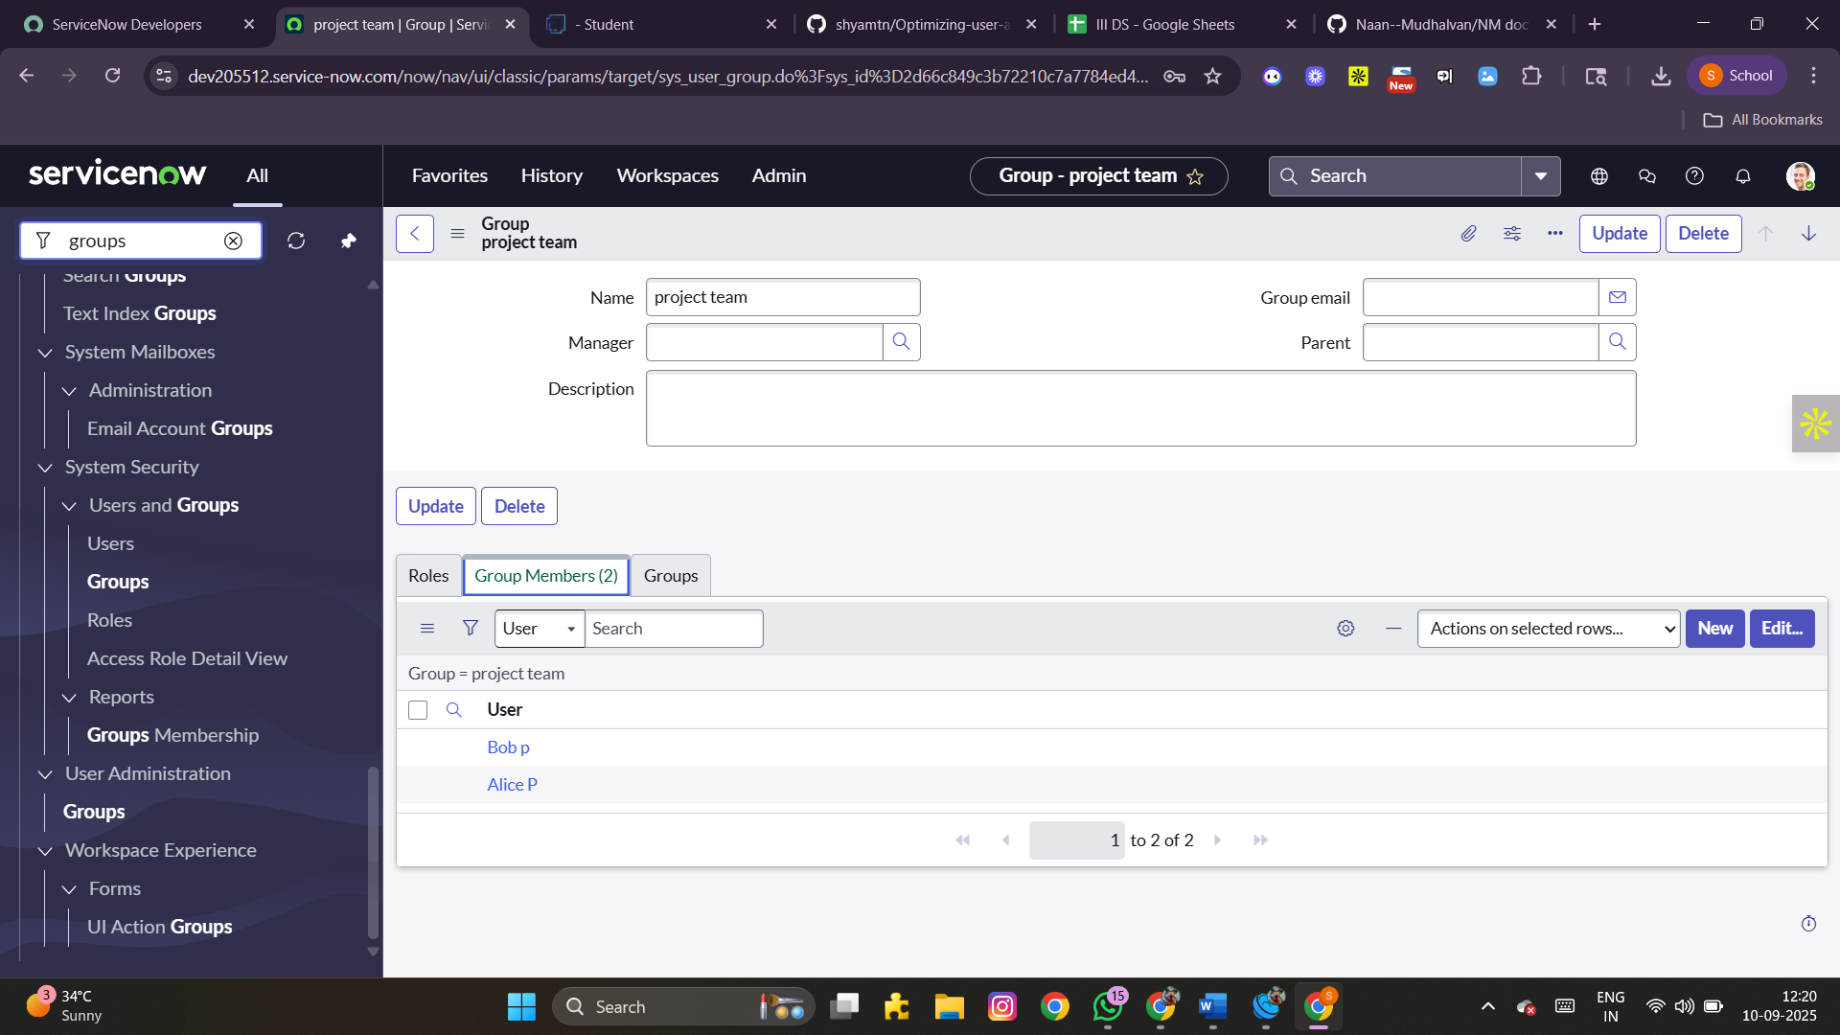

**STEP 6: ASSIGN ROLES TO USERS**

**Assign roles to Alice (Project Manager)**

1. Navigate to All → Users.
2. Select *alice p*.
3. Under the Roles tab, click Edit.
4. Assign the role *Project Member*.
5. Additionally, add roles: *u_project_table* and *u_task_table*.
6. Save and update the record.

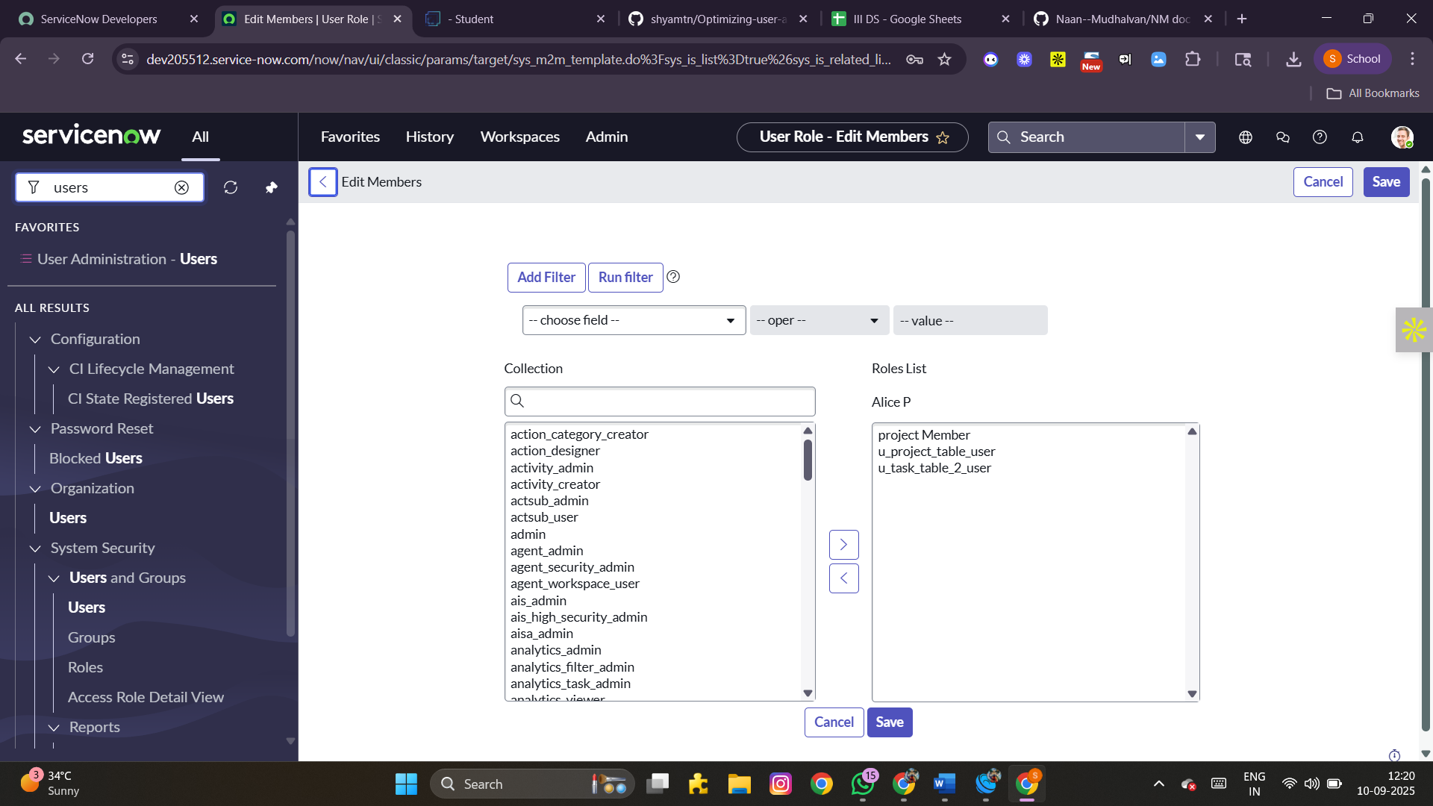

**Assign roles to Bob (Team Member)**

1. Navigate to All → Users.
2. Select *bob p*.
3. Under the Roles tab, click Edit.
4. Assign the role *Team Member*.
5. Save changes.

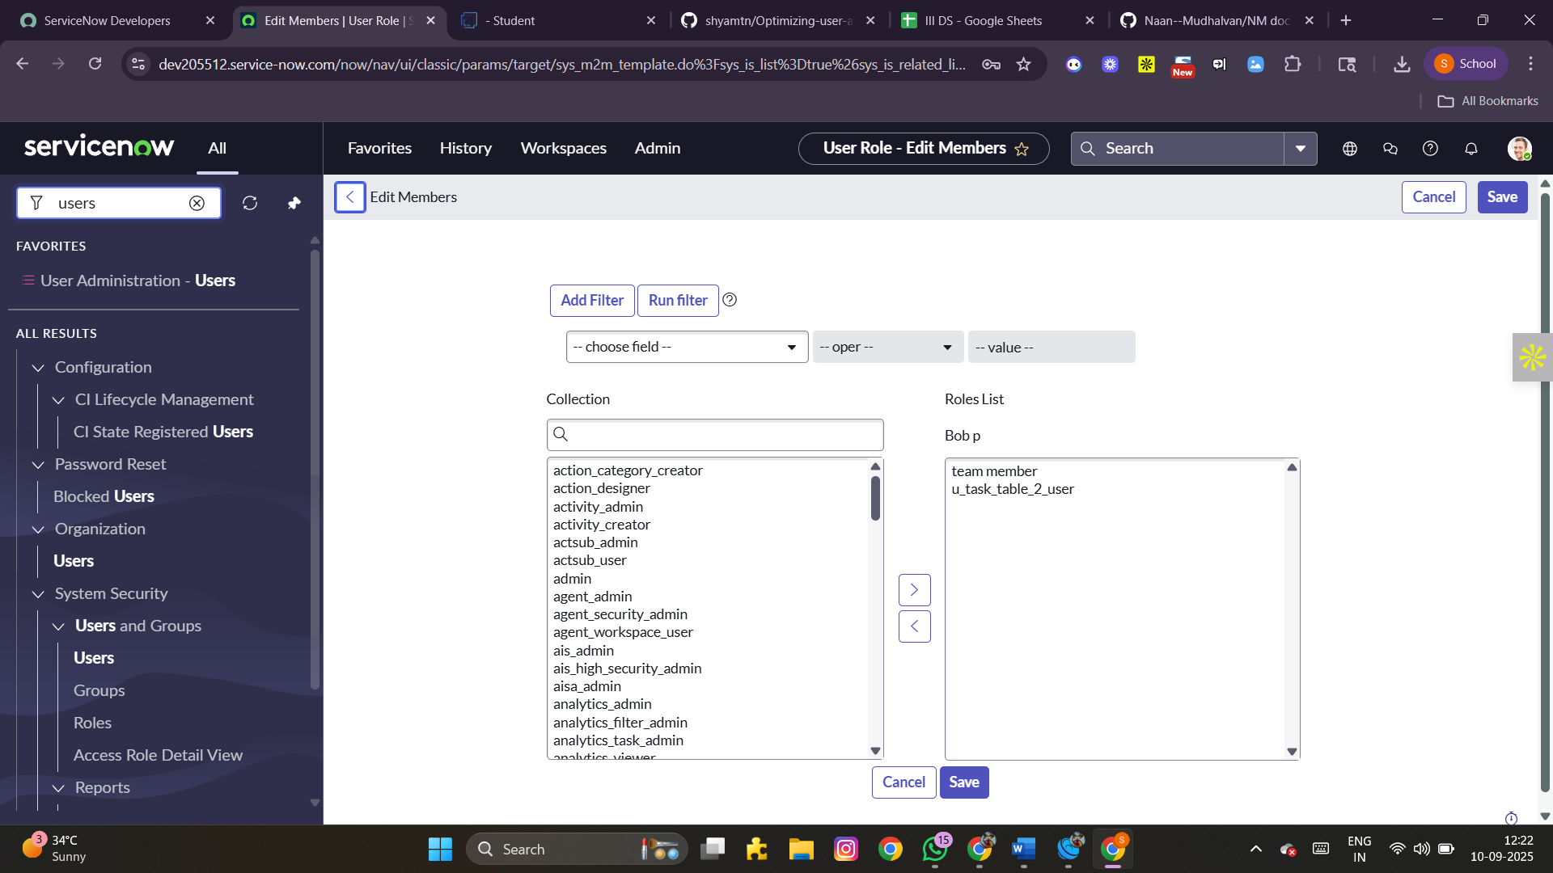

1. Use Impersonate User → bob p to verify access.
2. Confirm that *task table2* is visible.

**STEP 7: APPLICATION ACCESS**

**Assign Table Access to Applications**

1. When a new table is created, ServiceNow automatically generates an application and module.
2. Search for the *Project Table* application in the Application Navigator.
3. Edit the module settings.
4. Grant access to the *Project Member* role.
5. Search for *task table2* in applications.
6. Edit the application and assign both *Project Member* and *Team Member* roles.

**STEP 8: ACCESS CONTROL LIST (ACL)**

**Create ACLs**

1. Go to All → ACL.
2. Select Access Control (ACL) under System Security.
3. Elevate role (if required).
4. Click New.
5. Fill in the ACL details.
6. Under Requires Role, add a new row.
7. Assign *task table* and *Team Member* role.
8. Click Submit.

Create multiple ACLs:  
9. Repeat the process to create 4 additional ACLs for relevant fields.

Validation:  
10. Click the profile icon → Impersonate User.  
11. Select *bob p*.  
12. Navigate to task table2 in the Application Navigator.  
13. Verify that *Comment* and *Status* fields are editable.

**STEP 9: FLOW**

**Build a Workflow using Flow Designer**

1. Open Flow Designer (All → Flow Designer under *Process Automation*).
2. Click New → Flow.
3. Provide Flow Name: *task table*.
4. Select Application: *Global*.
5. Click Build Flow.

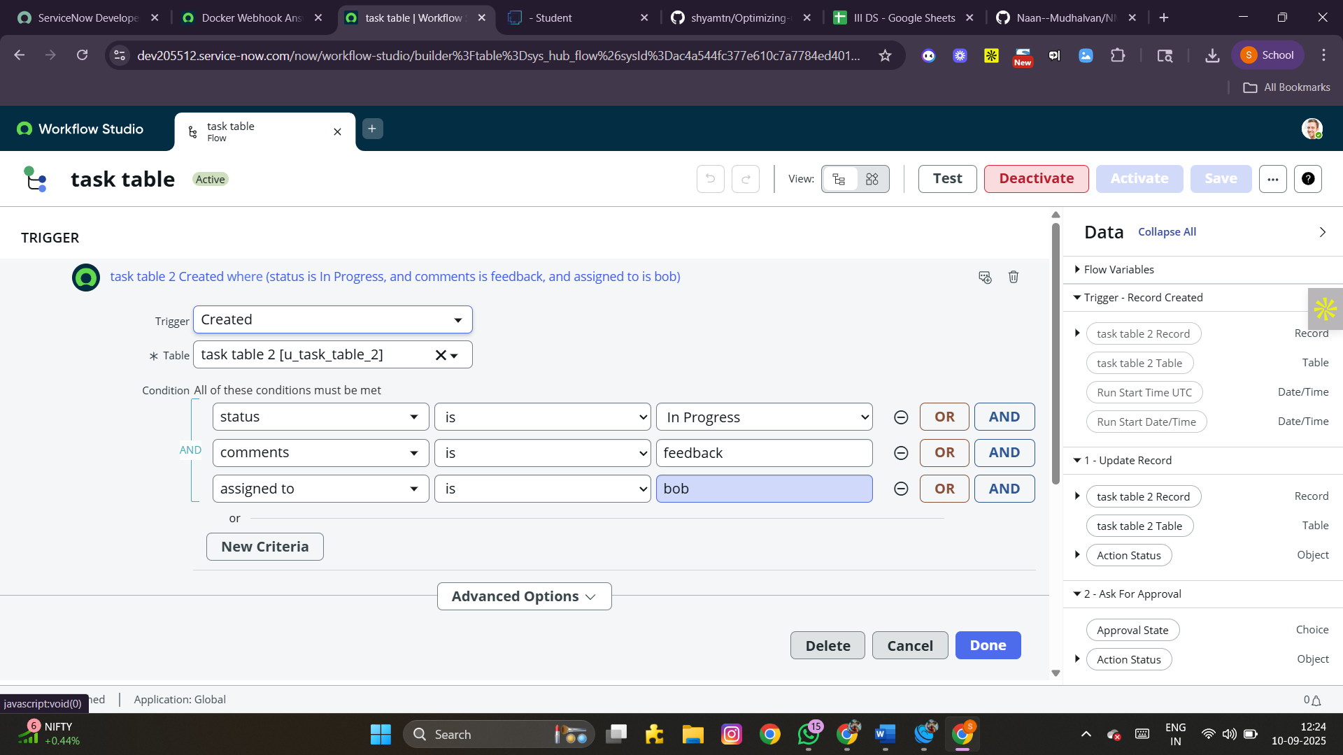 **I: Add Trigger**

1. Add a trigger → choose *Created Record*.
2. Table: *task table*.
3. Set conditions:
   * Status = In Progress
   * Comments = Feedback
   * Assigned To = bob
4. Click Done.

**II: Add Action – Update Record**

1. Add an action → choose *Update Record*.
2. Select fields from Data Pills.
3. Set *Status = Completed*.
4. Click Done.

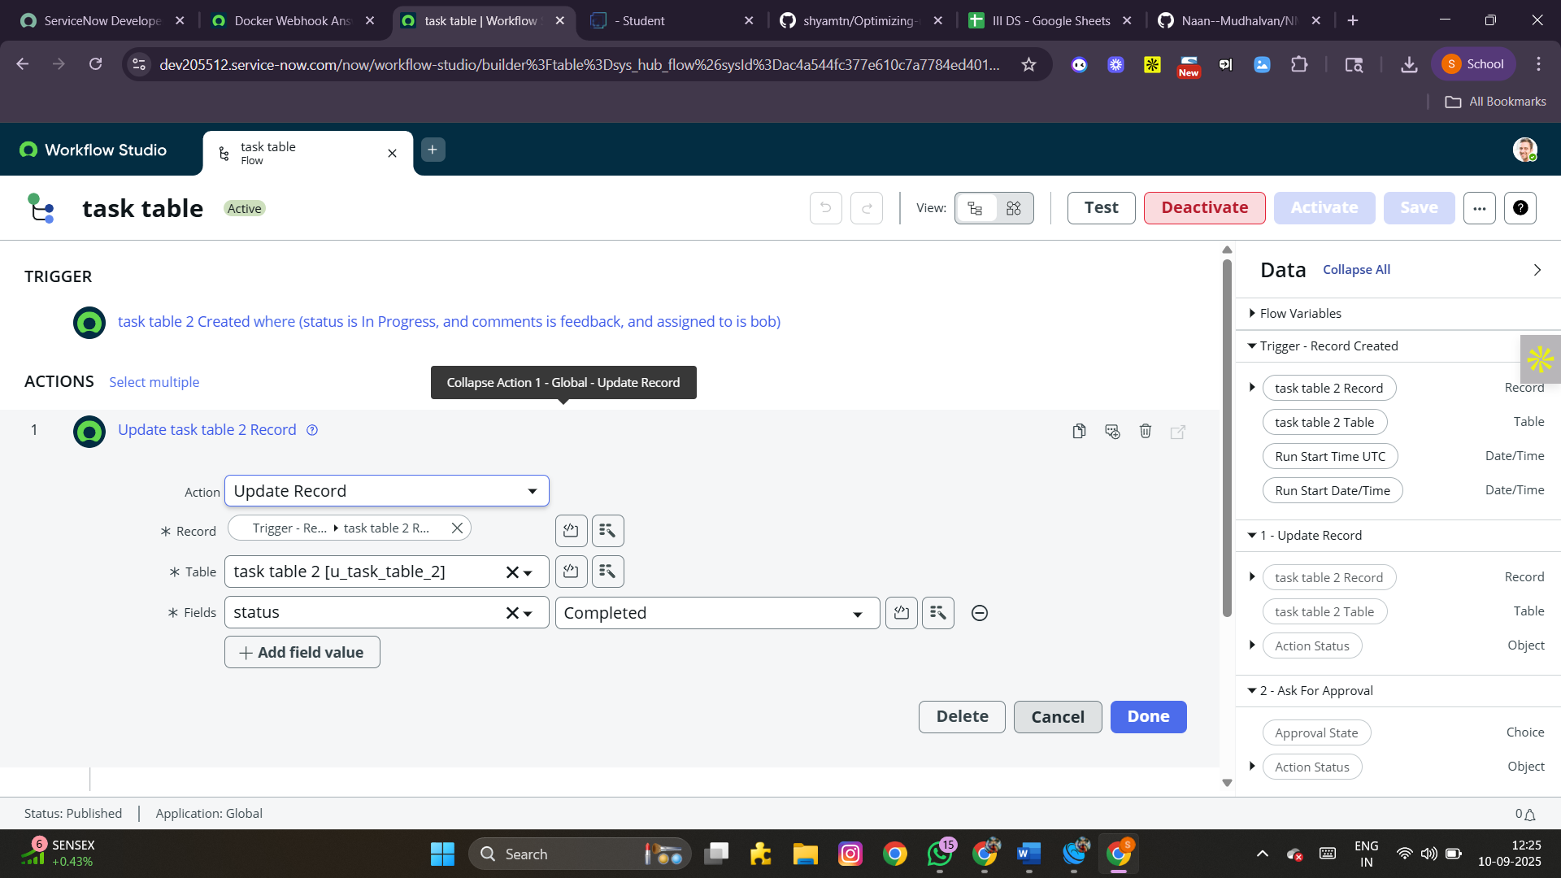 **III: Add Action – Approval**

1. Add another action → choose *Ask for Approval*.
2. Map required fields.
3. Set *Approval Field = Status*.
4. Approver = *alice p*.
5. Click Done.

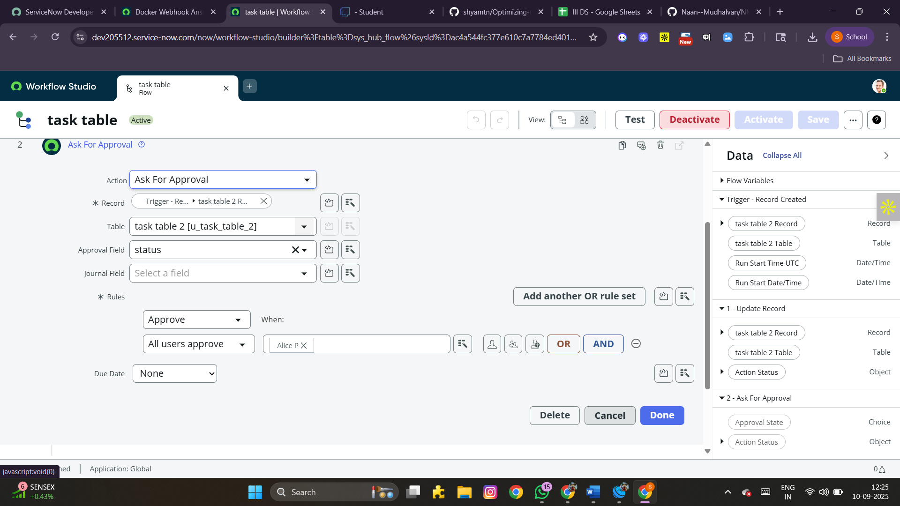 **VALIDATION :**

1. Go to task table2 application. Confirm that status updates to *Completed*.
2. Navigate to My Approvals under Service Desk.
3. Check that *alice p* receives the approval request.
4. Approve the request to complete the workflow.

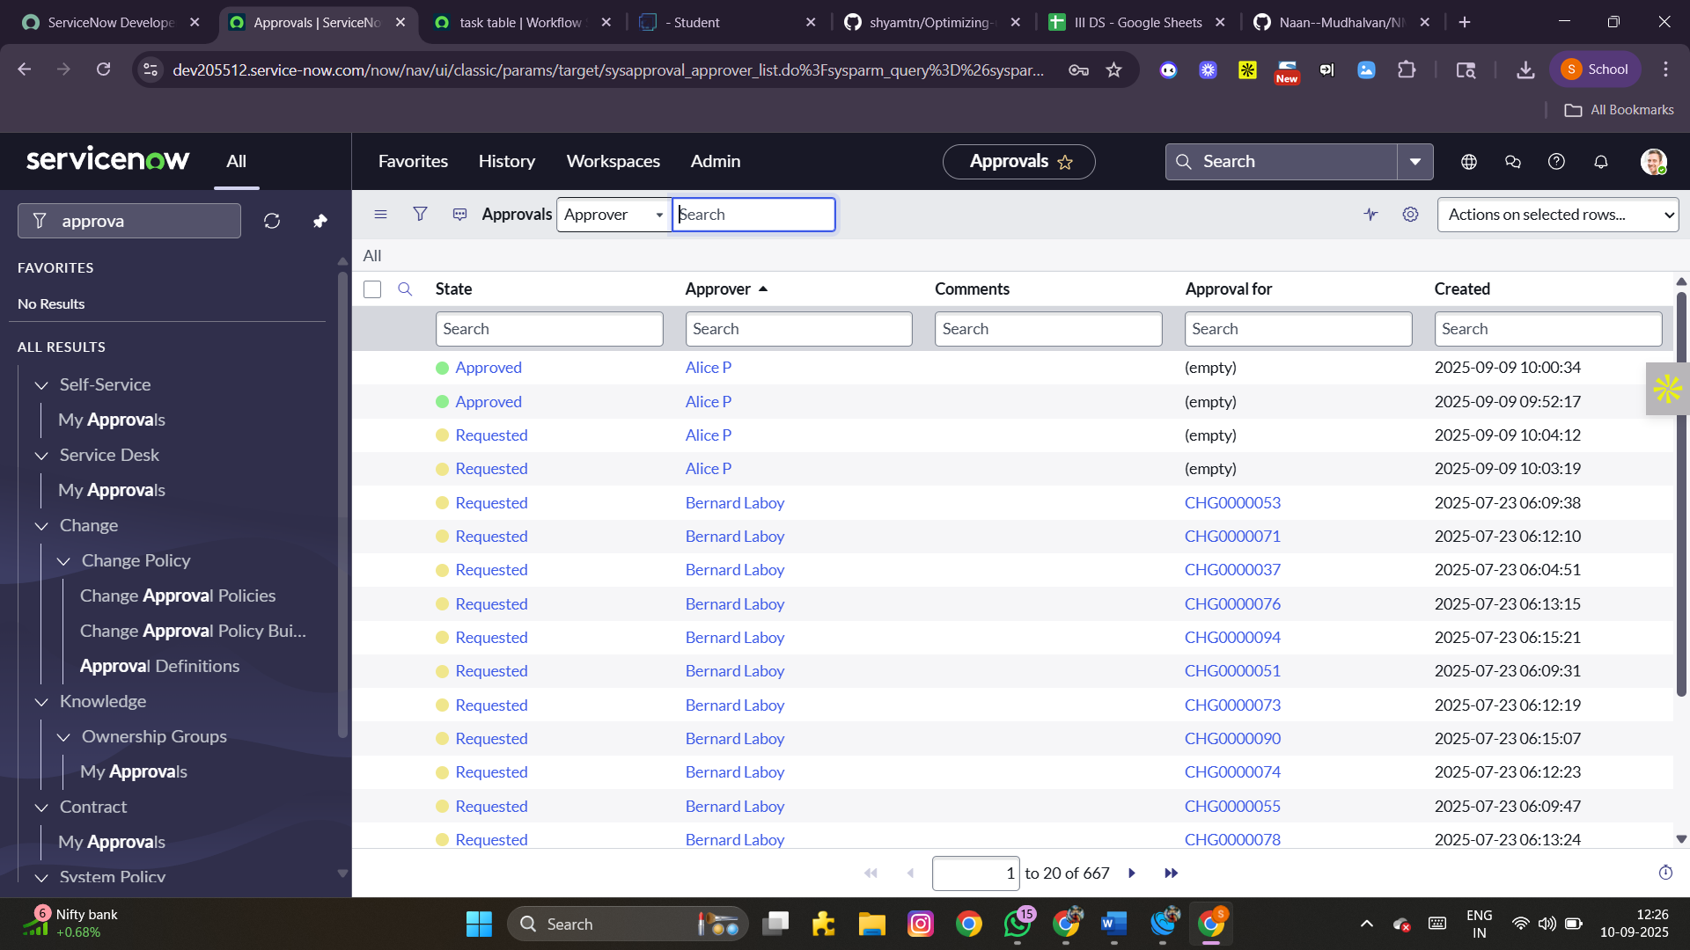

**CONCLUSION :**

Through this project, we successfully implemented a ServiceNow Workflow Management System. The key outcomes include:

* **Structured creation of users, groups, and roles**
* **Proper assignment of application access and ACLs**
* **Automated workflows with approvals and status updates**
* **Verified access for multiple users with role-based permissions**

This configuration demonstrates how ServiceNow can streamline IT operations, improve security, and automate repetitive tasks efficiently.